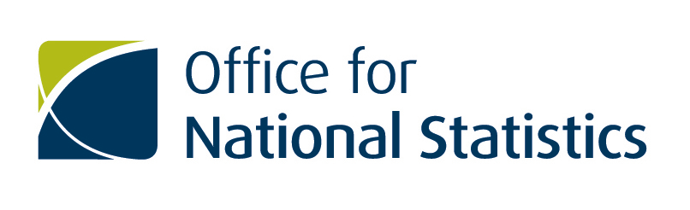

MSc Data Analytics for Government
Framework Agreement

Customer Guidance

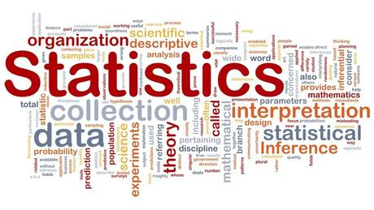

Ref: PU-0017-0279

Period: 01st March 2016 to 31st August 2019
(with an option to extend for a further 24 months to 31st August 2021)

Version 2 April 2017

Contents

Section | Page
- Overview | 3
- Supplier Information | 4
- Using the Framework | 5
- Alternative Courses | 6
- Framework Terms | 7
- Contract Management | 7
- Background to the Procurement | 7
- Evaluation of Offers | 8
Annexes
A. Specification and Framework T&C’s | 9
B. Framework Suppliers Pricing schedules | 9
C. Customer Registration Form | 9
D. Points to Consider | 10
Key Contact Details
Contact ONS via:
Ceri Regan – Data Capability, GSS Professional Support
0300 062 5465
gss.capability@ons.gsi.gov.uk

Sheila Powell – Head of Commercial Services
01633 456478
sheila.powell@ons.gsi.gov.uk

Jessica Payne – Commercial Contracts Manager
01633 456945
jessica.payne@ons.gsi.gov.uk

Dr Solange Correa-Onel – Academic Manager, Data Science Campus
01329 444378
datacampus@ons.gov.uk

1. OVERVIEW

The ONS Learning Academy is pleased to launch the first MSc in Data Analytics for Government Framework Agreement, which offers a new solution for Government Statistical Service staff wishing to continue to education and obtain a recognised qualification.

The Framework provides staff with the opportunity to pursue an MSc training pathway to develop their career within Government. The framework content was designed to address the specific learning needs of Government and includes a range of modules, compulsory and optional which have been assessed as being fundamental to building a career in statistics and data science within Government.

The full Service Specification used within the procurement is attached as Annex A.

1.1 WHO CAN USE THIS FRAMEWORK?

This Framework can be used by all Government Statistical Organisations:
https://www.gov.uk/government/organisations

1.2 BENEFITS OF THE FRAMEWORK

- It’s quick and easy to use.

- All Suppliers and Services are managed under one Framework.

- The Framework is EU compliant so there is no need for you to run a full EU tender for your requirements.

- Pre-agreed Terms and Conditions. All Suppliers on the Framework have agreed to the Framework Terms.

- Centrally Managed. ONS will manage the Suppliers on the Framework, receiving regular Management Information and holding regular Supplier reviews.

- Supplier’s capability guaranteed. All Suppliers listed on the Framework have already been assessed for their course provision and academic resources.

- The framework allows prospective students and their line managers to select the University which best meets their learning needs without the need for a future competition.

- Programmes will be tailored to your individual requirements. Students will be able to select on the basis of available course options.

- University Selection – Call Off – Form

2. SUPPLIER INFORMATION

Provider | Programme Lead | Contact Email | Contact Telephone
Oxford Brookes University | Dr Rachel Long, Principal Lecturer and Programme Lead for Mathematics | TBC | TBC
University College London – Centre for Data Science | Prof Patrick Wolfe, Course Director | TBC | TBC
University of Southampton | Paul Smith, Associate Professor | TBC | TBC

3. USING THE FRAMEWORK

3.1 The framework allows prospective students to select their preferred University based on the available learning modules and methods of study:

Step 1: Please use the funnelling tool to determine the most suitable provider based on the requirements of the student.
Step 2: Student to apply to selected University, quoting usage of Framework, Ref PU17/0279.

Step 3: Please contact ONS to confirm acceptance by University and provide details of the selected modules. This information will assist us to develop future iterations of the Framework.

3. FRAMEWORK AWARD SUPPLIER(S) Module Information
3.1 – Supplier Matrix
Modules | Core/Optional | University of Southampton | Oxford Brookes | ULC – Data Science
Statistics in Government: | Core Modules | Yes | Yes | Yes
Data Science Foundations | Core Modules | Yes | Yes | Yes
Survey Fundamentals: | Core Modules | Yes | Yes | Yes
Statistical Programming | Core Modules | Yes | Yes | Yes
Introduction to Survey Research | Optional modules | Yes | Yes | Yes
Regression Modelling | Optional modules | Yes | Yes | Yes
Data visualisation | Optional modules | Possibly | Yes | Yes
Evaluation and Monitoring | Optional modules | Yes | Not available | Not available
Economics and National Accounts | Optional modules | Yes | Not available | Not available
Survey Data Collection | Optional modules | Yes | Yes | Yes
Further Survey Estimation Methods | Optional modules | Yes | Yes | Yes
Index Numbers | Optional modules | Yes | Not available | Not available
Demographic Methods | Optional modules | Yes | Yes | Not available
Statistical Disclosure Control | Optional modules | Yes | Not available | Not available
Advanced Statistical Modelling | Optional modules | Yes | Yes | Yes
Time Series analysis | Optional modules | Yes | Yes | Yes
Small Area Estimation | Optional modules | Yes | Not available | Yes
Spatial Analysis | Optional modules | Yes | Yes | Yes
Bayesian (probabilistic) methods | Optional modules | Yes | Yes | Yes
An Intro to Machine Learning | Optional modules | Possible | Yes | Yes
Advanced Machine Learning | Optional modules | Possible | Yes | Not available
Intro to distributed systems | Optional modules | Not available | Yes | Yes
Data Mining | Optional modules | Yes | Yes | Yes
Applied Data Mining | Optional modules | Not available | Yes | Yes
Advanced Programming for Data Analytics | Optional modules | Not available | Yes | Yes
Delivery Options
Part time Day |  | Not available | TBC | TBC
Part time Evening |  | Not available | TBC | TBC
Part time Weekend |  | Not available | TBC | TBC
Part time Block Release |  | Yes | TBC | TBC
Other |  | Not available | TBC | TBC

4. Alternative Courses
ONS recognise that the Framework may not provide sufficient geographical coverage for use across Government and therefore have reviewed a number of alterative MSc programmes.
If you require more information regarding alternatives programmes and study options, please contact Ceri Regan, GSS Professional Support, gss.capability@ons.gsi.gov.uk

5. FRAMEWORK TERMS
All Customer Organisations are reminded that whilst the contract is between the relevant Supplier and the participating Customer Organisation, the Framework Agreement Terms and Conditions will apply to all orders placed under this Agreement.

This Framework Agreement is subject to the Framework Terms and Conditions issued by the ONS at the time of tendering.

6. CONTRACT MANAGEMENT
Users of the Agreement should be aware that participating Suppliers are required to provide accurate management information on the use of the Agreement throughout its term.
The Suppliers will submit termly information regarding student enrolments, modules taken and progress. The Suppliers will also provide Customer Organisations with their own management information regarding their student population as and when requested.
From time to time, Customer Organisations may be required to respond to urgent requests for information. Suppliers will be expected to provide the requested information within 24 hours of receipt of request, unless agreed in advance with the organisation.

7. BACKGROUND TO THE PROCUREMENT

This procurement exercise was conducted by the ONS, on behalf of the GSS to establish a broader learning solution.
The University of Southampton has run an MSc programme jointly with the ONS/GSS for more than 15 years, providing 46 MSc, 42 Dip, 10 Cert and more 300 CPD modules.
The expiry of the contract in 2017 offered the opportunity to widen the provider base and provide a greater geographical spread of provision, whilst continuing a specific learning pathway for Government.
We identified 4 compulsory modules which the GSS considered as essential for the member of the Profession to study and a range of optional modules to cover different requirements across the service.
Users of the Agreement should be aware that participating Suppliers are required to provide accurate management information on the use of the Agreement throughout its term.
8 . EVALUATION OF OFFERS

The evaluation of bids was undertaken by three evaluators providing a cross sector discipline assessment.
The evaluators independently assessed the technical questionnaire responses for the relevant Lot(s) using the scoring guidance included in the ITT.
Following these individual evaluations a “Consensus Scoring” exercise was conducted to arrive at a single consensus score agreed for each question and criterion set
The three awarded Universities provided detailed information regarding their course content and their academic credentials.
Users of the Agreement should be aware that participating Suppliers are required to provide accurate management information on the use of the Agreement throughout its term.

ANNEX A: Specification and Framework Terms & Conditions
Project Information

Framework Terms & Conditions and Specification

ANNEX B: Framework Pricing Schedules & Funnelling Tool
Funnelling Tool

ANNEX C: Registration Form
Registration Form

Annex D : Points to Consider
Query | ONS Response
Can the student select any of the Framework providers? | Yes. The decision regarding the chosen programme is for the student and their line manager to agree.
Can I take individual modules? | Yes , the Framework has priced for the full MSc programme and individual modules, therefore students can select individual modules.
Are the prices submitted at Framework stage the prices Customer Organisations will pay? | Yes, providers have given details of the costs for the programme and individual modules.

