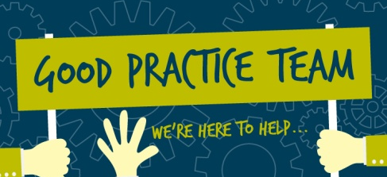
Government Statistical Service
Good Practice Team - 2016 Secondment Opportunity

The Good Practice Team was created to help enable the Government Statistical Service (GSS) to be the best that it can be. Our role is to promote and share statistical good practice across the GSS and create opportunities for collaboration within and between departments. To help facilitate our work, we’re offering existing GSS members the chance to join the GPT on short term secondment.

What’s on offer?

The chance to spend between 2 and 4 weeks working as part of the Good Practice Team, based in either our London or Newport office.

You’ll be given the opportunity to see how the Good Practice Team operate and to get involved in delivering our ambitious work programme. You’ll also gain an understanding of the work of the GSS Presentation and Dissemination Committee, learning more how this group provides strategic direction in the GSS. Whilst being fully supported during your time with the GPT, you’ll be given a distinct task to make your own, based on your areas of interest and the skills you bring. This blog from Nicola George from the DfT describes the work she undertook as the first secondee on the scheme.

Who should apply?

Anyone who is enthusiastic, innovative and passionate about improving official statistics! We’re looking for people who are self-motivated and focused on delivering at pace. This opportunity is open to GSS members at all grades and we expect it to be of particular interest to Assistant Statisticians, Higher Statistical Officers and Senior Statistical Officers.

How do you apply?

The secondment opportunity must be funded by the parent department. Therefore, interested candidates must discuss this opportunity with their line manager and Head of Profession to ensure that the secondment is permitted. Once you have agreement from your line manger, please contact the Head of the Good Practice Team to discuss further (Martin Ralphs, 0207 5928650, goodpracticeteam@statistics.gsi.gov.uk).

What work do the GPT do?
Our work draws heavily on the Better Statistics, Better Decisions and the Code of Practice for Official Statistics. The team’s interventions include developing and promoting guidance and case studies, supporting producers to meet UK Statistics Authority assessment requirements, designing and delivering seminars and workshops, consultancy and creating and supporting collaborative, cross-government networks. The GPT’s work is aligned closely with the strategic priorities of the UK Statistics Authority Monitoring and Assessment Team and the GSS Presentation and Dissemination Committee. GPT also directly supports emerging priorities from the National Statistician.
Our priority areas are:
- Presentation and Dissemination of Official Statistics
- User Engagement
- Smarter analysis and use of evidence Casework
- Monitoring Reviews and support for Assessment
Who does the secondment benefit?
A good secondment benefits everyone. The GPT values the skills, experience and fresh perspective brought by the secondee. The secondee gains new skills and experience which they may not have been able to get in their own organisation – which in turn benefits their organisation when the secondee returns. The links built across the GSS can also be highly valuable.

