Proceedings of the 22nd GSS Methodology Symposium 2017
Methodology: Insight; Innovation; Implementation; Impact

Anticipating Brexit Effects in Time Series Analysis

Jennifer Davies; Duncan Elliott; Charlotte Gaughan; Atanaska Nikolova

Abstract

The outcome of the European Union referendum and the exiting of the United Kingdom from the EU could have a widespread impact on economic time series produced by the Office for National Statistics. The impact could manifest itself in the form of outliers, level shifts and ramps at the end of a time series, which can be difficult to identify and categorise correctly. Failing to account for these correctly can lead to revisions to seasonally adjusted series and forecasts when they are later detected. We aim to minimise the impact of revisions to ensure an accurate and reliable estimate of the economy. This paper presents an empirical study of univariate options for modelling shocks, taking in to account previous research in the field. A consideration is also given as to whether incorporating expert Economists views on Brexit effects in to models, is a worthwhile approach.

Key Words: time series, seasonal adjustment, forecasting, outliers

1. Introduction

1.1 Motivation and Background

The analysis of economic time series in the context of official statistics typically involves seasonal adjustment or forecasting. Seasonal adjustment is related to estimating and removing effects that have a repetitive pattern each year (for example, sales increasing in the period around Christmas) and can potentially mask underlying trends in the data. Forecasting involves estimation of future data points in order to inform decisions in a timely manner. Once true data is available, forecasted values are replaced with real ones.

The good quality of both of these procedures is dependent on the quality of the data and prior knowledge of the impact of economic events. Atypical events, such as one-off outliers or sustained level shifts, can disturb the regularity of the time series and thus need to be modelled in order to produce realistic forecasts and adequate seasonal adjustment. However, in the time of economic uncertainty or crisis, it is difficult to anticipate perturbations at the end of the time series as possible effects may be delayed or take an unexpected turn. One recent example is the outcome of the EU Referendum in June 2016, which became widely known as “Brexit”. This event is expected to have a widespread impact on British economy, but the exact direction, magnitude or timing of this impact is not known.

Previous research by Kirchner and Mehrhoff (2012) suggested that failing to model outliers at the time of economic uncertainty can lead to unrealistic seasonally adjusted values and artificial turning points up to a year after the impact of the event. In turn, this means large revisions to the seasonal adjustment once the impact of the event is established. It was suggested that it may be beneficial at times of uncertainty to treat each incoming data point as an outlier until the true state of affairs can be established. Although such a technique may be useful for accounting for true outliers in a timely manner, it may also be damaging due to mis-classification or overfitting, which also can result in unwanted revisions.

The current study aimed to test several methods that can be applied to potentially minimise revisions to seasonally adjusted data and decrease forecast errors in the face of economic uncertainty. The principal aim was to eventually apply this to the period after the EU Referendum, but due to insufficient data available to perform empirical tests at the time, the time period after the 2008 economic downturn was used instead.

1.2 Time Series Analysis at the Office for National Statistics

The time series analysis branch at the Office for National Statistics analyses thousands of economic time series. The main parameters used for seasonal adjustment are reviewed once a year and then fixed until the next review in order to minimise revisions. It is at these review points that additive outliers (one-off deviations from the typical pattern of the data, usually for a single data point), levels shifts, ramps (successive level shifts), seasonal breaks (sustained changes in the seasonal pattern of the series), or any other potentially disturbing events are identified. Their effect is estimated and removed before seasonal adjustment is performed, that is, the series is cleaned or prior-adjusted. This cleaning, as well as forecasting, is performed with a method called regARIMA modelling, and then seasonal adjustment is performed with the X-11 method, which is based on iterative sequence of moving averages. After seasonal adjustment, the effect of outliers and level shifts is put back into the series so that it can be visible by the user. This procedure is done with the X-13ARIMA-SEATS software (Findley, Monsell, Bell, Otto, & Chen, 1998).

1.3 Impact of Outliers

Outliers can be very problematic for both seasonal adjustment and forecasting. Therefore, their effects need to be accounted for in the model by specifying the specific data points at which they are believed to occur. The X-13 software also has a capability for automatic detection of outliers. However, this is particularly challenging at the end (and beginning) of the time series, as a level shift cannot be distinguished from an additive outlier. Not accounting for a level shift, for example, can lead to volatile seasonally adjusted values in the vicinity of the event (Figure 1.3.1). Also, misclassifying a level shift for an outlier (or vice versa) can lead to a wrong level of the forecasts.

Figure 1.3.1.
Seasonal adjustment comparison with and without a level shift correction for Public Sector Employment. NSA = non seasonally adjusted; LS = level shift
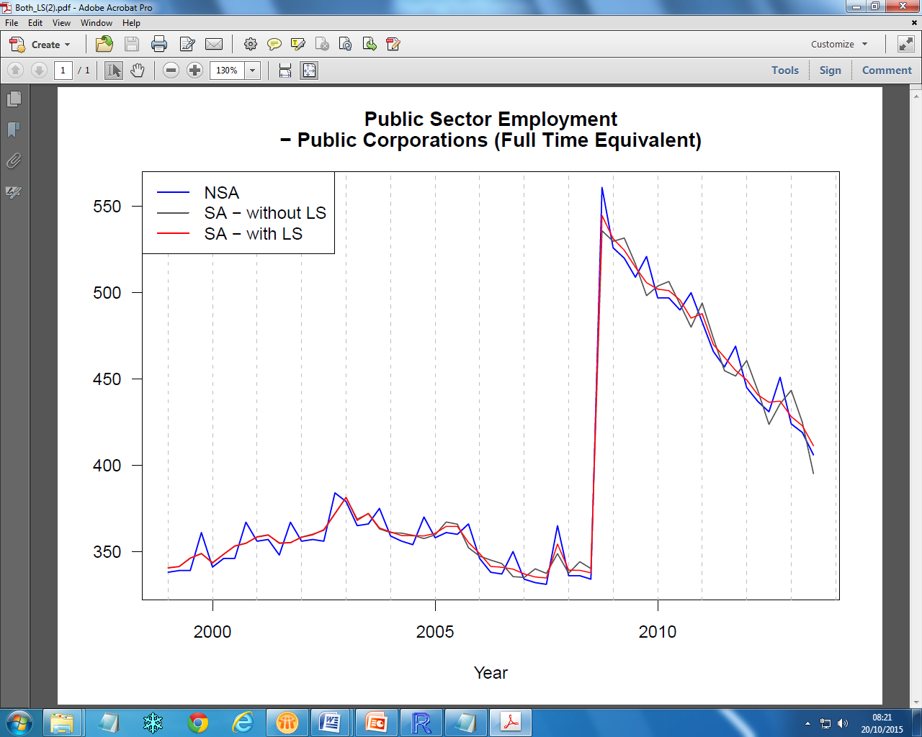

Ultimately, the wrong treatment of outliers, whether that is false negative or false positive, can lead to poor seasonal adjustment and forecasts, which can be detrimental for official statistics and in the context of making important decisions or informing policy.

2. The Current Study

2.1 Considered Options for Dealing with Uncertainty

Six options aimed to minimise the effect of unknown shocks at the end of time series were tested. The options are applied to all future points starting at the period of uncertainty until this period if over and the true effects can be identified. The results were assessed in relation to seasonal adjustment revisions and one-step ahead forecast error. The six options were the following:

- Treat all future time points as additive outliers.
This was the method suggested by Kirchner & Mehrhoff (2012). It will be beneficial for capturing true outliers and can also account for the effect of level shifts and ramps in the case of seasonal adjustment. However, misclassifying can be damaging for forecasts.

- Treat all future points as level shifts.
Same principle as additive outliers. Misclassifying can lead to erroneous level of forecasts.

- Use automatic outlier and level shift detection for all future observations.
Using the capability of X-13ARIMA-SEATS. This can lead to fewer misclassifications, but as new data comes the type of past outliers can change and lead to unstable seasonal adjustment.

- Shorten the trend filter by a magnitude of 2.
The trend filter is a special case of moving average applied as part of the X-11 algorithm and it only matters for seasonal adjustment. Shorter filter can be expected to make the trend more sensitive to turning points and outliers.

- Lengthen the trend filter by a magnitude of 2.
A longer filter may be expected to produce a smoother trend that is less affected by outliers.

- No intervention.
This will spare unnecessary revisions due to mis-specifications or overfitting, but it will fail to account for any shocks to the time series.

2.2 Data and Method

Seasonal monthly series were used from Index of Production, Index of Services, and Trade in Goods. The data were grouped into series that exhibit the following effects anywhere in 2008: additive outliers (28 series), level shifts (50 series), ramps (18 series), seasonal breaks (4 series), no effects (586 series). Each of the six interventions were applied on all series, starting from January 2008 until December 2009. That is, one data point was added at a time and seasonal adjustment and one-step ahead forecasting performed each time. Each series was cleaned from any effects other than the one associated to the group it belonged to for 2008, so it only exhibited the relevant effect in 2008 and no other shocks were present.

Absolute percentage one-step ahead forecast error as new data points were added until December 2009 was averaged across each series as a function of each group (actual effect exhibited). First-to-final absolute revisions to the seasonally adjusted values were calculated using the formula: R_{t} = (SA_{t}|_{T} - (SA_{t|t}) / SA_{t}|_{t} , where SA_{t}|_{T} is the seasonally adjusted value for point t given the full span of the data up to T, and SA_{t|t} is the concurrent seasonally adjusted value of the reduced span with t being the latest data point. Again, these values were averaged across all series as a function of the actual affect exhibited in 2008 and the applied intervention. The filter intervention only applied to seasonal adjustment revisions as it makes no difference for forecast errors.

3. Results

3.1 Forecast Error

Table 3.1.1 represents the mean and median one-step ahead forecast error for each group of series as a function of intervention type. Median is also presented as the data was not normally distributed. The results suggest that when a series exhibited a level shift, the best intervention was fitting level shifts to all data points, or not making any adjustments. For series with additive outliers, the best intervention was to use automatic outlier detection provided by the software, and for series with ramps, adjustment for level shifts was the favoured option. Finally, no intervention resulted in lowest forecast errors when the series had a seasonal break or no outliers at all. The differences between the interventions are not always large, but overall it appears that using automatic detection or not performing any intervention are the best outcomes for forecasting.

Table 3.1.1
Mean and median (in parenthesis) one-step ahead forecast error (January 2008 to December 2009). Values in bold indicate the lowest errors.
Intervention type | Actual effect present in series
 | Level shift (N=50) | Additive outlier (N=28) | Ramp  (N = 18) | Seasonal break  (N =4) | No effect (N=586)
All AO | 27.461  (18.287) | 28.099  (16.633) | 29.532  (22.197) | 6.446  (5.091) | 21.723  (12.426)
All LS | 9.501  (5.511) | 22.238  (9.892) | 5.137  (3.098) | 6.671  (5.205) | 14.334  (6.489)
Automatic selection | 10.043  (5.722) | 15.991  (8.756) | 7.367  (3.438) | 6.112  (4.529) | 11.434  (5.872)
No intervention | 9.464  (5.555) | 18.557  (9.686) | 5.691  (3.322) | 3.913  (1.816) | 11.189  (5.790)

3.2 Seasonal Adjustment Revisions

Table 3.2.1 presents the mean results for first-to-final absolute revisions of the seasonally adjusted values. For series with level shifts, additive outliers or ramps, the best intervention was the use of the automatic outlier detection capability. For series with seasonal breaks, lowest revisions were produced by lengthening the filter, but making no intervention was also favourable. For series without any effects shortening the trend filter or making no intervention led to the best outcome.

Table 3.2.1
Mean absolute first-to-final (2016) revisions (January 2008 to December 2009). Values in bold indicate the lowest revisions.
Intervention type | Actual effect present in series
 | Level shift (N=50) | Additive outlier (N=28) | Ramp  (N = 18) | Seasonal break  (N =4) | No effect (N=586)
All AO | 2.247 | 4.591 | 1.297 | 4.982 | 3.360
All LS | 2.247 | 4.591 | 1.297 | 4.982 | 3.360
Automatic selection | 2.169 | 3.770 | 1.232 | 4.974 | 2.681
Short filter | 2.384 | 4.291 | 1.759 | 3.377 | 2.643
Long filter | 2.399 | 4.314 | 1.711 | 3.205 | 2.653
No intervention | 2.384 | 4.292 | 1.733 | 3.248 | 2.643

4. Discussion

Based on the current results, there is no option that clearly stands out as the best, but it appears that making no intervention or using an automatic outlier detection procedure are favoured. This is not too surprising, as over-fitting additive outliers or level shifts continuously is likely to lead to worse results due to many false positive corrections to the series, given that there may be just a single outlier or level shift. This fits well with the outcome that level shift adjustments were best for series with ramps, as ramps are indeed a succession of level shifts. Therefore, in such cases over-fitting would not be as damaging as for other effects. It may be best to not do any intervention in anticipation, until enough data is available to make an informed decision. The cost of waiting until the uncertainty is reduced seems to be less than over-adjusting in advance. This method is indeed what is currently practiced at the ONS, as seasonal adjustment parameters are fixed in-between revision periods, which typically happen once a year. For forecasts there is no practice to do annual parameter review, they are more often done on ad-hoc basis, or using automatic methods, which is the other favoured outcome from the current study.

Future considerations would involve testing these methods on actual post-Brexit series. Some work that the Time Series Analysis Branch conducted recently on the amount of seasonal adjustment revisions before and post the June referendum indicated evidence that revisions are becoming large for the post-referendum periods, especially in some series (Retail Sales Index). Therefore, there is enough data to apply the current methods. Also, future direction would involve multivatiate analysis and using leading indicator series to inform possible changes in the target series in a timely manner and be able to fit appropriate prior adjustments at the end of the time series, rather than use an over-fitting technique.

References

Findlay D, Monsell B, Bell W, Otto M, Chen C (1998) New capabilities and methods of the X-12-ARIMA Seasonal-Adjustment program, Journal of Business & Economic Statistics, Vol.16, No.2 (Apr 1998), pp 127-152

Kirchner R and Mehrhoff J (2012) The role of outlier detection and replacement in practical seasonal adjustment, Workshop on Recent Advances in Seasonal Adjustment. Available online:
http://ec.europa.eu/eurostat/cros/system/files/WSSAThe%20role%20of%20outlier%20detection%20and%20replacement.pdf (last accessed on 30/08/17)

Atanaska Nikolova, Office for National Statistics, atanaska.nikolova@ons.gsi.gov.uk; Charlotte Gaughan, Office for National Statistics; Jennifer Davies, Office for National Statistics; Duncan Elliott, Office for National Statistics;

