Exploring mental well-being from prisoner casenotes using text mining
Joanna Lee

Abstract
Evidence on people with mental health and substance misuse is costly to commission, yet these individuals are over-represented in the prison population. The most recent Adult Psychiatric Morbidity Survey of prisoners, published almost 20 years ago (Singleton et al., 1998), found that over 90% had one or more of five studied psychiatric disorders (psychosis, neurosis, personality disorder, hazardous drinking, and drug dependence).
To address this gap in knowledge, text mining techniques were explored on prisoner casenotes, where prison officers enter free text to describe prisoners’ progress. The casenotes are written in an ad hoc fashion, recording interactions that range from formal interviews/meetings to chance encounters. The casenotes contain information about prisoner well-being which can be explored to determine mental health despite gaps in timelines for prisoners, a large variation in length or detail of case notes, and no pre-defined coding or structure of information.
Here, I will explore the challenges faced by handling such large datasets (5 million casenotes are recorded each year), and how to explore the relatively imprecise mental health text data, as recorded by non-specialists. Mental well-being is not easily categorised, but if done properly can provide rich context for prisoners throughout their time in custody. Having encoded mental health issues from the casenotes, MoJ analysts are using them to improve predictive analytics (e.g., the risk of committing violent acts while in custody) and implementing an R Shiny application allowing operational staff to view a summary of issues logged across a prisoner’s case note history.
Keywords: text mining; NLP; R Shiny; predictive analytics

1. Introduction
There has been a lot of media attention in recent years, criticising the safe-guarding of vulnerable individuals in prisons. A recent NICE guidance publication explored the mental health of individuals across the justice system (NICE Guidelines, March 2017). Here, it was found that there is “low quality evidence for a range of systems for the delivery and coordination of care in the criminal justice system”, which indicates a gap in our knowledge at an estate-wide level.
Surveys conducted in prisons are costly, and have very low participation. Therefore they are not conducted regularly, and the few completed surveys provide us with an incomplete picture. One of the more recent surveys was conducted in 1998 (Singleton, et al., 1998), the Adult Psychiatric Morbidity Survey of prisoners indicate that over 90% of prisoners had one or more of the 5 psychiatric disorders studied (psychosis, neurosis, personality disorder, hazardous drinking, and drug dependence). The MoJ advanced analytics team was therefore commissioned to explore the existing administrative data to try to narrow the evidence gap.
One such data source is the prisoner casenotes, which are recorded by prison officers and describe their interactions with prisoners. The casenotes are free text entry boxes, therefore are a potentially rich data source for analysis. This paper addresses the difficulties in tackling such a large data set. The aims of the project are, first to determine whether the casenotes can be used in the first instance to explore mental health in prisoners? Second, if the casenotes can be used, how can mental health be tied in with other, external trigger factors such as drug/alcohol issues, vulnerability/bullying, debt, or smoking? Finally, are the casenotes an effective way to investigate and monitor mental health issues?

2. Methodology
The methodology for this project can be split into 4 major processes:
- The pre-processing of the casenotes, and misspelling replacement in the text
- Curation of a mental health dictionary of terms
- Classification of the casenotes
- Determining the polarity of the casenotes, i.e. whether a casenote has a negative or positive emotional valence.
These processes feed into the workflow described in Figure 2-1. The first process is the most involved, and required the most attention in order to ensure the highest quality and integrity of the data in order to capture the most out of subsequent analysis.

Figure 2-1.
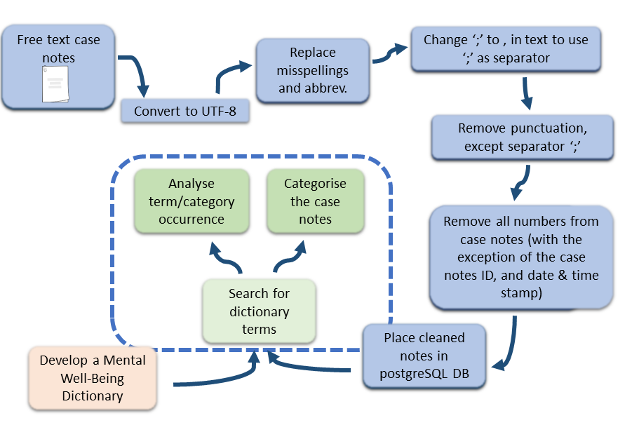
The workflow for the pre-processing and analysis of the prisoner casenotes. The cleaning of the casenotes was the longest, and most involved process, as captured in the first 6 steps of the workflow.

2.1 Pre-processing
Due to the large dataset of 20 million casenotes from 5 years, it was not possible to put these into RAM greedy applications, such as R or python, as our current system had only 32 GB of RAM. Therefore a bash script was developed for the pre-processing pipeline, which had a massive advantage over R or python because it reads and processes a file line by line, rather than having to load the whole file into RAM. The bash script contains commands to do the following:
1.) Convert to UTF8 encoding for each CSV file in a directory using ‘iconv’, and then save to a new file:
for file in *.csv; do # change file directory for case note dump
iconv -f ISO-8859-1 -t UTF-8 "$file" > "${file%.txt}.utf8.converted"
echo "Converting "$file""
done
for file in utf8.converted; do # create one file to process
cat "$file" >> utf8.tmp
rm "$file" # deletes the old, temporary files after UTF-8 conversion
echo ""$file" added to utf8.tmp"
done

2.) Remove duplicate lines (‘!seen[$0]++’), multiple concurrent punctuation occurrences (using the tr command), and any unprintable characters (and the carriage return using sed 's/[^[:print:]\r\t]/ /):
cat utf8.tmp | awk '!seen[$0]++' | tr -s '[:punct:]' | sed 's/[^[:print:]\r\t]/ /g' > tidy_casenote.tmp
echo "tidied tmp"

3.) Call the awk script, which will replace misspellings, and abbreviations in the casenotes:
gawk –f awk_dict.awk > casenotes_cleaned.txt
The awk script is in Figure 2, which also provides a selection of misspellings which are contained in the separate dictionary file, misspellings_dict.txt. The awk script loads the misspellings and their correct spelling into memory, and then searches each line for a misspelling, replacing it with the correct spelling before printing to file.

Figure 2.1-1.
The awk script, awk_dict.awk (A) called by the bash script in order to replace misspellings in the casenotes. Awk is used for this process for the speed of its processing, as well as the simplicity of its use for replacing words in a file using an array matching misspellings, abbreviation and acronyms with full, correct spellings (B).
(A)
i'm ---> i am
hadn’t ---> had not
wasn’t ---> was not
abscence ---> absence
adress ---> address
approx ---> approximate
arv ---> alcohol related violence
behavoiur ---> behaviour
behavour ---> behaviour
BEGIN { FS = ","
while (getline<"misspellings_dict.txt") {
dict[$1] = $2
}
FS = " "
}
{
for (i = 1;i<=NF;i++) {
if ($i in dict) {
$i = dict[$i]
}
}
print $0
}
(B)

2.2 Mental Health dictionary
The mental health dictionary was curated with help from Department of Health, as well as policy colleagues. Another useful piece of guidance came from operational documents for prison officers. The result was that 3 broad themes were used to capture mental health terms.
- Clinical History
• Mental illness diagnosis (e.g. depression, bipolar disorder, schizophrenia)
• Personality disorder diagnosis (e.g. borderline personality disorder)
- Psychological and Psychosocial Factors
• Desperate, Angry, Sad, Ashamed, Hopeless, Worthless, Lonely, Disconnected, Powerless
- Current context
• Recent suicide/self-harm thoughts/actions
• Violence, intimidation or fear of these
• Parole refusal or other knock-back
• Longer sentence than expected
• Alcohol/drug misuse
• Irrational behaviour, out of touch with reality
• Recklessness
• Hostile rejection of help

2.3 Classification
After some exploratory analysis, it was evident that the casenotes covered a huge scope, some of which was not directly related to mental health. In order to select for casenotes of relevance, the casenotes were categorised according to the prisoner’s current context (see part 3 above), as well as particular areas of the prison such as canteen, chaplaincy, gym, work, or education. Casenotes were manually categorised according to the words they contained, for example the chaplaincy category would contain casenotes mentioning chaplain or church. This provided useful context for further investigations, since a lot of the mentions of mental well-being in the casenotes would be with the backdrop of the life of a prisoner. In particular, mention of family or relations would appear in conjunction with mental health issues, especially if there was a bereavement.

2.4 Polarity
In order to apply a sentiment score to the casenotes, the ETEA algorithm (Kirk, C., ETEA algorithm) was implemented, adapted to the specific text in the prisoner casenotes. The scoring of casenotes by ETEA is controlled by the presence of words in two dictionaries. The first dictionary is a list of key words, manually curated, that relate to the specific mental health terms that occur in the casenotes, and this was constantly updated with subsequent exploratory analysis. The second dictionary contains terms that assign the polarity (negative or positive words), and the strength (weak or strong) of the polarity to associated with that word. Therefore the number of words that are from the first dictionary, weighted by their polarities from the second to provide the final polarity score. This score has both a negative, and positive component that can be summed to get an overall sense of the casenote. After several iterations to improve the first dictionary so that it accurately provided the context for mental well-being (the second dictionary was taken straight from the ETEA algorithm), the assignment (positive, neutral, negative) matched a manual assignment in 65% of the test set of casenotes.
X became very emotional and starting to cry when asked about a recent visit. X missed his children and wanted to be dead.
Taking the above statement (not a real casenote) as an example “emotional”, “cry”, “missed”, and “dead” are picked up as being negative by the algorithm. However “wanted” is picked up as positive, which shows how difficult it is to address ambiguous words that could have multiple meanings. Regardless, the polarity of the phrase is negative overall.

Table 2.4-1
An example of how the ETEA algorithm works. It takes every occurrence of a word that exists in dictionary (A) and will sum these to give the magnitude of the score, given the occurrence of a word in dictionary (B).
Dictionary (A) words from example  The context of the casenote | Dictionary (B) words from example  The polarity of the casenote
Children | Emotional – strong, negative
Cry | Cry – strong, negative
Emotional | Miss – weak, negative
 | Want – strong, positive
 | Dead – weak, negative
Since there are 3 words from dictionary (A), the weighting for the dictionary (B) words is 3x the scoring for emotional, cry, miss, want, and dead.

3. Discussion
The methodology splits into 4 parts, and the first part which is the pre-processing of the data is both quick to implement, and addresses a major obstacle to text analysis by replacing misspellings in the casenotes. The second step, curating a mental health dictionary, was not trivial due to the way casenotes are recorded. Prison officers are not medical experts, nor are the casenotes meant to act as medical notes, therefore non-medical language is typically used to describe mental health. This has exceptions, as some terms are now in common language, such as ‘depression’, However care needs to be taken as this is often used in a colloquial sense; ‘he is feeling a bit depressed’ could easily mean ‘he is feeling a bit down’ rather than ‘he has been clinically diagnosed as having depression’. Since many words were not present in the casenotes, the mental health dictionary was reduced to the most commonly occurring terms.
There is a further bias in the casenotes that relates to what prison officers find relevant at any given time. Since there is no obligation to record many things, unless a prison officer is specifically asked to record a certain thing, then it will most likely be omitted as most are under tremendous pressures in their jobs. One obvious example of this is the omission of individuals with no serious mental health problem. Instead, often a positive casenote occurs for individuals whose mental well-being is in a constant state of flux and the prison officer is recording a good day for the individual. A second area of bias may come from what a particular prison finds relevant and wants information about. The best example of this is the introduction of novel psychoactive substances into the prison black market which has caused a lot of issues in recent years, and so has had increased prominence in casenotes.
For the third step, which was building categorical tags for the casenotes, these were eventually manually curated. Other techniques were explored for this, however the casenotes are so varied in the language that they use, automated processes could not categorise as well as expert input for the prisoner casenotes. The polarity scoring algorithm, ETEA, was more successful as it builds on existing sentiment analysis, honing it to the particular situation. As with all similar techniques, they are only as good as the analyst’s knowledge of the data.

4. Conclusions and Future Directions
In the absence of data in this subject area, the casenotes provide some insight into mental health in prisoners. However there are many limitations in the casenotes; the lack of technical language making it difficult to identify specific mental health issues in more depth than the polarity score; an unknown bias in what is omitted from the casenotes, especially when the average recording rate is 1 casenote per week; and the language used in the casenotes varies a lot between prison officers, and prisons.
However, the casenotes do provide insight into what prisons, and prison officers, are seeing and provides details across the whole estate. The casenote analysis can be used to best effect when explored in conjunction with external factors (drug/alcohol issues, vulnerability/bullying, debt, or smoking), as well as other administrative data sets. The appropriateness of the casenotes is therefore varied, and will perhaps be better placed to provide a timeline for prisoners with known mental health issues, rather than in a predictive sense to determine if all individuals with mental health issues are being discovered, and treated.
Given the above caveats, the methodology used in this paper has potential for use in predictive models that are being developed within the team. Its inclusion in the models could provide an insight into the well-being of individuals within the prison estate.

5. References
- ETEA algorithm, Chris Kirk, https://github.com/chriskirkhub/etea.

- NICE guidelines, (March 2017), Mental health of adults in contact with the criminal justice system, https://www.nice.org.uk/guidance/ng66/resources/mental-health-of-adults-in-contact-with-the-criminal-justice-system-pdf-1837577120965.

- Singleton N., Meltzer H., Gatward R., Coid J., Deasy D. (1998) Psychiatric morbidity among prisoners in England and Wales. London, the Stationery Office.

Ministry of Justice (MoJ), joanna.lee@noms.gsi.gov.uk

