Proceedings of the 22nd GSS Methodology Symposium 2017
Methodology: Insight; Innovation; Implementation; Impact

The Impact of Moving Holidays on Official
Statistics Time Series
Bethan Russ, and Tariq Aziz

Abstract

A major challenge faced when seasonally adjusting time series is accounting for annual events that move dates from one calendar year to the next, for example, Easter. If these events are not accounted for appropriately it will impact on the estimation of seasonal factors, and leave systematic calendar related effects in the seasonally adjusted series.
Currently the Time Series Analysis Branch (TSAB) tests for Easter effects and, if identified, estimates and removes them as part of seasonal adjustment. This method assumes that daily activity changes by a fixed amount or proportion for a given number of days before Easter Sunday and remains at this level until Easter Saturday.
There are other moving holidays celebrated in the UK, which may have an impact on time series despite not being public holidays. These are Chinese New Year, Ramadan, Eid al-Fitr and Eid al-Adha. Currently these holidays are not adjusted for in any seasonally adjusted time series published by the Office for National Statistics (ONS).
TSAB has undertaken research to test alternative windows for Easter effects and whether other moving holidays have identifiable effects on ONS time series.
This presentation will present the methodologies used in the research and the findings on a range of ONS time series.
Key Words: time series; seasonal adjustment; calendar effect; moving holiday; regARIMA

1. Background

A moving holiday is defined as a calendar event that moves between periods, where a period can be a week, month or quarter, from one year to the next. (In this research a year is defined as a solar year, based on dates of the Gregorian calendar.) Well-known examples of these events are Easter, Chinese New Year, Ramadan, Eid al-Fitr and Eid al-Adha - all of which are widely celebrated in the UK.
As with many annual events, a moving holiday can cause seasonality in a time series. However, since these events do not occur in the same period each year, without an appropriate adjustment the estimation of the seasonal component may become distorted and the resulting seasonally adjusted series may contain systematic variation due to the arrangement of the calendar.
At present TSAB only tests and adjusts, where appropriate, ONS time series for an Easter effect, where activity throughout the Easter period is assumed to be of a fixed amount or proportion and only pre-Easter Sunday windows are considered (see Section 2.1). Any effect resulting from other moving holidays, alternative windows or amounts which are not constant are not currently accounted for.
Moving holiday effects are estimated through the inclusion of appropriate regressors in a regARIMA model. This research project aims to develop, and test, alternative regressors. These regressors aim to account for the following:

- UK moving holidays:
  - Chinese New Year
  - Eid al-Adha
  - Eid al-Fitr
  - Ramadan
- Different lengths and positions of windows around the moving holiday
- Alternative shapes of regressor about the moving holiday (ie an effect which is not assumed to be a fixed amount or proportion):
  - Constant - known generally as Shape 0
  - Linear - known generally as Shape 1
  - Quadratic - known generally as Shape 2.

2. Methodology

2.1 Current Methodology

To account for the moving date of Easter Sunday TSAB currently tests and applies, if appropriate, one of three different Easter regressors. These regressors have been built into X-13ARIMA-SEATS [Bureau, 2016] to account for the fact that Easter can fall in one of two months (March or April) in a monthly series or in one of two quarters (quarter 1 or quarter 2) in a quarterly series. (Note: X-13ARIMA-SEATS is the recommended software for time series analysis across the Government Statistical Service (GSS).)
The three Easter regressors currently used in production are Easter[1], Easter[8] and Easter[15], the standard built-in regressors which account for the North American Easter holiday period. The Easter[1] regressor is used to account for Easter Saturday only. The Easter[8] regressor accounts for Easter Saturday and the 7-day period that precedes this. The Easter[15] regressor accounts for Easter Saturday and the 14-day period that precedes this. Each of the three regressors is a Shape 0 and assumes that activity changes by a fixed amount or proportion across the period it covers.

2.2 New Methodology - Easter

Whilst the built-in regressors are adequate for accounting for Easter, and the days preceding this, they do not adequately account for the Easter period in the UK. In the UK there are bank holidays either side of Easter Sunday, on Good Friday and Easter Monday, and school holidays which generally fall both sides of Easter Sunday, dependent on the date of Easter Sunday. The bank holiday and school holiday periods could have an effect on movements in a time series. Two UK specific Easter regressors were constructed and tested on a number of high profile series.
As part of the exploratory analysis, to identify whether or not an Easter effect was present, Easter proximity charts were constructed for each series analysed. These charts were constructed by mapping the irregular component from the time series which has been decomposed without accounting for an Easter effect, for both March and April, against the date of Easter Sunday in a given year.
An example of one of these series, which shows a possible Easter effect, can be seen in Figure 2.2-1 below. This chart is for Index of Production: Manufacture of other non-metallic mineral products (other). The most notable feature of Figure 2.2-1 is that when Easter Sunday falls in March, the value of the March irregular is negative and the April irregular is positive. The magnitude of the irregular decreases as the date of Easter Sunday moves closer to April. When Easter Sunday is in April there is no obvious pattern to the irregular component.

Figure 2.2-1
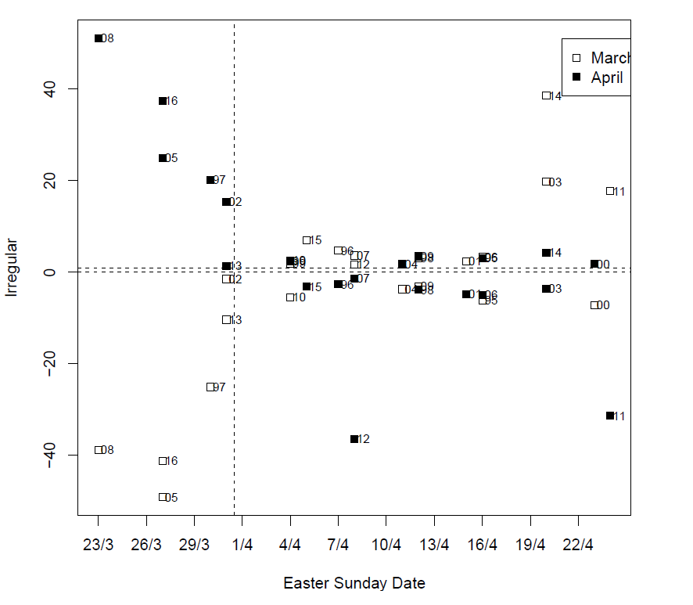
Easter proximity chart.

Following the exploratory analysis, two UK Easter regressors were constructed and tested, UKE[4] and UKE[12]. The UKE[4] regressor covers the period from Good Friday to Easter Monday, accounting for the entire UK bank holiday period. The UKE[12] regressor runs from the Monday before Easter Sunday until the Friday following it, a period which is similar to UK school holidays. Both the new UK Easter regressors assume that activity changes by a fixed amount or proportion over these periods and have been built as a Shape 0 to account for this.
The performance of the new UK Easter regressors was assessed on 599 current ONS time series. Each series was modelled independently with no Easter effect, the standard regressors in X-13ARIMA-SEATS; Easter[1], Easter[8], Easter[15], and the UK specific regressors; UKE[4] and UKE[12].
The Akaike information criterion-corrected (AICC) value, produced by X-13ARIMA-SEATS, was recorded for each series and each regressor. The regressor resulting in the lowest AICC value was recorded as the most appropriate Easter regressor for that series. The best Easter regressor was then compared against the Easter regressor currently used in the seasonal adjustment of that time series.
It should be noted that the AICC value is a crude estimate of the performance of a regressor. In practice the AICC value would be used in conjunction with further knowledge, further tests and continuity analysis before such regressors are put in the production of official statistics (see Section 4.1 for information on further work).
Extracts of the UKE[4] and UKE[12] regressors can be found in the Appendix. The information on the built-in regressors can be found in the X-13ARIMA-SEATS manual [Bureau, 2016].

2.3 New Methodology – Chinese New Year and Islamic Calendar Events

There are currently no methods in place to account for the moving holidays Chinese New Year, Ramadan, Eid al-Fitr or Eid al-Adha. With these events becoming more prominent in the UK it was important for TSAB to construct regressors and analyse whether or not these events are having an impact on official statistics.
For the analysis of Chinese New Year, Eid al-Fitr and Eid al-Adha 8 regressors were constructed for each moving holiday - where the regressor was centred around day 1 of each moving holiday. The regressors were constructed as two groups of four - with the first four regressors taking the form of Shape 0 and the remaining four Shape 1. Within each group there were the following four windows:
- (7,0) - the 7 days leading up to the event and the event itself
- (14,0) - the 14 days leading up to the event and the event itself
- (7,7) - the 7 days leading up to the event, the event itself and the 7 days following the event
- (14,14) - the 14 days leading up to the event, the event itself and the 14 days following the event
For the analysis of Ramadan three regressors were constructed. The first regressor, Regressor A, was constructed in the form of Shape 0 with the window covering the entire month of Ramadan itself. The second regressor, Regressor B, was also constructed as a Shape 0 and considered the fourteen days leading up to the start of Ramadan, and day 1 of Ramadan only. The third regressor, Regressor C, considered the same window as Regressor B but was constructed as Shape 1. Regressors with a window including dates after the end of Ramadan were not considered, as Eid al-Fitr is the first day after Ramadan and has been considered separately.
For each of the new moving holidays, dates spanning 100 years have been used to construct each of the regressors, centring them to align with the Gregorian calendar. Since the Chinese New Year windows considered can only fall (partially or wholly) in January, February or March, its regressors were centred by subtracting the means of January, February and March from the January, February and March values each year. The regressor is 0 for all other months.
Similarly, since the Islamic calendar events can fall in any month of the Gregorian calendar they were centred by subtracting the total mean of the build-up period from each month of the year. From here regARIMA modelling has been used to model the time series, which included the new regressors to assess the impact of these events. As with the Easter methodology, the AICC was recorded for each model to assess the most appropriate regressor for each time series that was analysed.
3. Results

3.1 Easter

In total there were 599 time series which were tested for Easter effects. Of these 167 time series, or 28% of them, deemed one of the two UK Easter regressors most appropriate, over the alternatives (which included no Easter effect). Table 3.1-1 below gives the high level summary of the counts of which Easter regressor was deemed most appropriate against each of the current regressors.
Table 3.1-1
Number of time series preferring each Easter regressor.
 | Easter Regressor with the Lowest AICC
 | No Effect | Easter[1] | Easter[8] | Easter[15] | UKE[4] | UKE[12] |  | Total
Current Regressor
No Effect | 262 | 26 | 16 | 19 | 20* | 23* |  | 376
Easter[1] | 25 | 15 | 3 | 4 | 39 | 54 |  | 140
Easter[8] | 7 | 2 | 8 | 0 | 0 | 10 |  | 27
Easter[15] | 15 | 1 | 5 | 23 | 4 | 8 |  | 56
Total | 309 | 44 | 32 | 46 | 63* | 95* |  | 599
*There are 10 time series, currently specifying no effect, that deem UKE[4] and UKE[12] equally most appropriate.
From Table 3.1-1 it can be seen that across all time series, those currently specifying the Easter[1] regressor saw one of the two UK Easter regressors outperforming the current regressor most often. There are currently 140 time series that contain an Easter[1] regressor and of these 93 deemed a UK Easter regressor most appropriate. This is approximately two thirds of the Easter[1] series tested. In contrast to this, series currently with no Easter effect included only deemed a UK Easter regressor most appropriate in 14% of cases.
Of the two UK Easter regressors the UKE[12] regressor was deemed the most appropriate most often. Across the 599 time series analysed the UKE[12] regressor was most appropriate in 95 instances and the UKE[4] regressor in 63 instances, in 16% and 11% of time series respectively. There were 10 instances where both the UKE[4] and UKE[12] regressors were both deemed equally most appropriate.
The assessment of which regressor is most appropriate has been made by considering the lowest AICC value only. No analysis has been done to look at the magnitude between the lowest AICC value and the AICC values for the other regressors. This analysis, along with other diagnostics, would be important in determining exactly how well each Easter regressor is performing.
To illustrate these results in a different way a chart has been created to show the difference between the seasonally adjusted series with no Easter regressor, the current Easter[1] regressor and the preferred UKE[12] regressor. Figure 3.1-1, to be consistent with Figure 4, has been plotted for Index of Production: Manufacture of other non-metallic mineral products (other). The results displayed in Figure 3.1-1 show a minimal difference in the seasonally adjusted values for the two Easter regressors, however a difference can be seen between these and no effect. It is possible that neither of these Easter regressors is fully capturing the proximity effect seen in Figure 4, and so other shaped regressors should be considered in any further analysis.
Figure 3.1-1
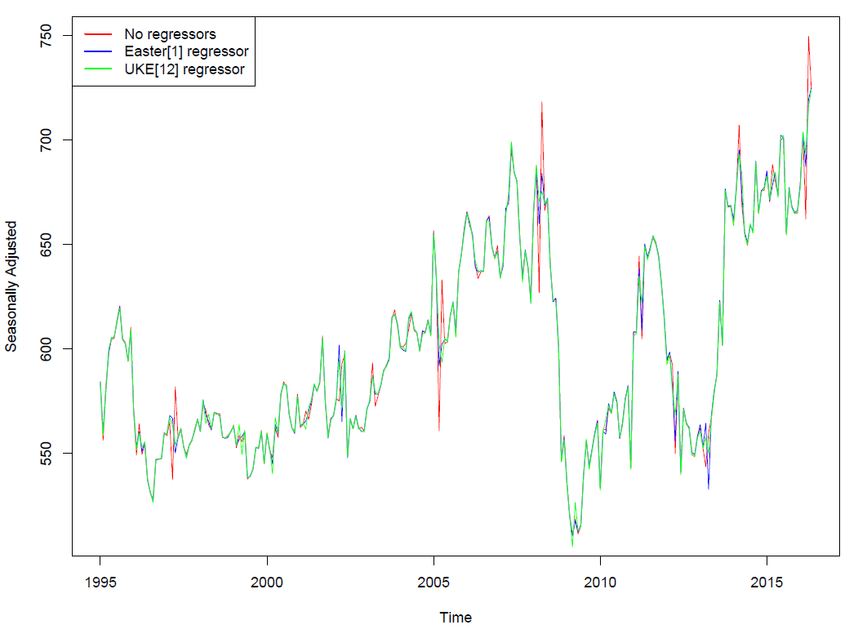
Seasonally adjusted time series, for three types of Easter regressors.

3.2 Chinese New Year and Islamic Calendar Events

In total there were 290 time series analysed for each of the further moving holidays. Of these 65 time series (22%) preferred a Chinese New Year regressor, 94 time series (32%) preferred an Eid al-Fitr regressor, 80 time series (28%) preferred an Eid al-Adha regressor and 91 time series (31%) preferred a Ramadan regressor, to no regressor for that event. Each moving holiday was assessed separately and the different windows and shapes were compared to no effect. Table 3.2-1 below gives a high level summary of the counts of which regressors were deemed most appropriate, for each moving holiday.
Table 3.2-1
Number of time series preferring each moving holiday regressor.

 | No Effect | Shape 0 |  |  |  | Shape 1
 |  | (7,0) | (7,7) | (14,0) | (14,14) | (7,0) | (7,7) | (14,0) | (14,14)
Chinese New Year | 225 | 2 | 9 | 12 | 9 | 13 | 0 | 6 | 14
Eid-al-Fitr | 196 | 5 | 7 | 21 | 12 | 9 | 6 | 4 | 30
Eid-al-Adha | 210 | 8 | 2 | 17 | 9 | 11 | 8 | 4 | 21
 | No Effect | Regressor A |  | Regressor B |  | Regressor C
Ramadan | 199 | 47 |  | 23 |  | 21

To show the impact of moving holiday regressors on time series seasonal adjustment process the seasonally adjusted time series have been plotted, see Figure 3.2-1, with and without Chinese New Year and Islamic Calendar regressors. This figure is for International Passenger Survey: Overseas visits to the UK, expenditure. This figure illustrates the results of the comparison of the seasonally adjusted series with no regressor included and moving holiday regressors for Chinese New Year and Islamic Calendar Events. This series has been chosen as it was one of the few that found an effect for all four moving holidays.
The regressors used in Figure 3.2-1 are Chinese New Year (7,0) Shape 1, Eid-al-Fitr (14,0) Shape 0, Eid-al-Adha (14,0) Shape 0, and Ramadan regressor A (Shape 0, full month). The results displayed in Figure 3.2-1 show a minimal difference in the seasonally adjusted values for no effect versus the moving holiday regressors. This could suggest that the effect is genuinely small, or that the analysed regressors are not fully capturing the shape of the effect, despite being preferred in a number of time series.
Figure 3.2-1
Number of time series preferring each moving holiday regressor.
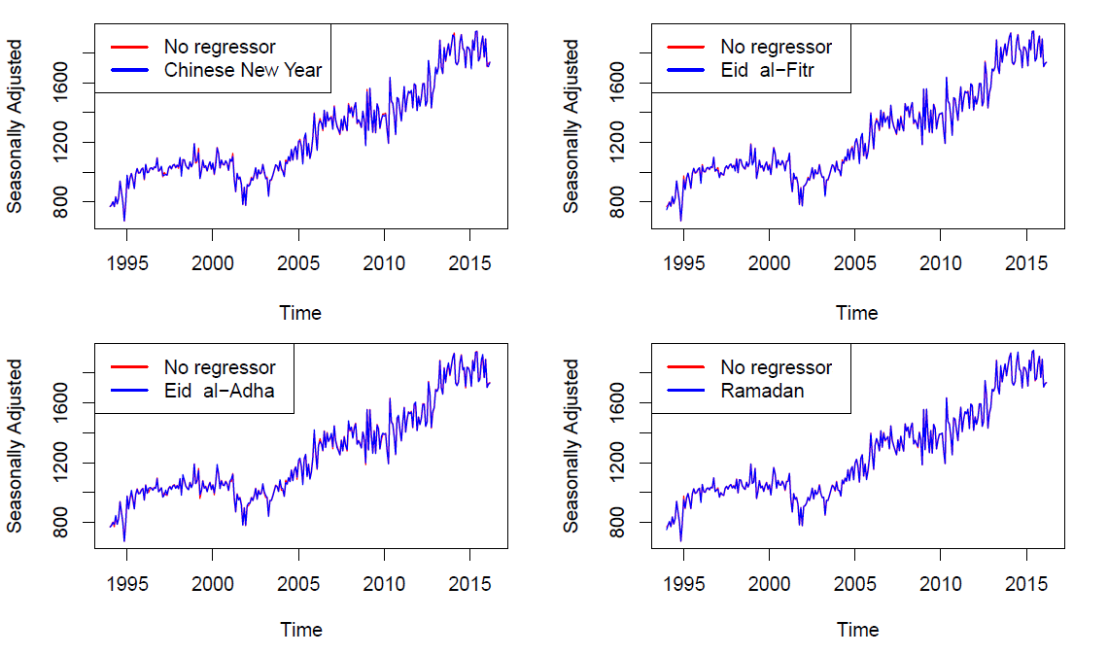

4. Conclusion

Although the results from this research show that the UK Easter regressors, Chinese New Year regressors and Islamic Calendar regressors do have an impact on some official time series, the results are not conclusive enough to implement these methods in production. In the cases of Easter regressors, there are instances where the current regressors are contained within the new UK Easter regressors. It would be interesting to look into what the additional effect of the extended period is, not necessarily the full four-day or two-week periods.
In comparison with any current methods for the respective holiday the Eid al-Fitr regressors were preferred the most, being preferred in 32% of time series. This was closely followed by the Ramadan regressors (31%) and the Easter & Eid al-Adha regressors (both 28%). The least preferred regressors were those for Chinese New Year, only being preferred in 22% of time series.
4.1 Further Work

There are a number of directions that this research can go from here. The main things to consider will be;
- Applying the new regressors to alternative series (for example, regional series or unconsidered outputs)
- Constructing and testing different shape regressors (for example, Shape 2 regressors)
- Constructing and testing regressors of alternative windows
- Using alternative diagnostics to assess suitability
- Considering the magnitude in the difference between the lowest AICC value and the other AICC values
- Analysing the interaction between moving holidays (for example - between Ramadan and the day after Ramadan, Eid al-Fitr).
Whilst attempting all these things would be ideal in expanding the research, they are not adequate in determining whether or not these regressors are appropriate for use in the production of official statistics. Every year TSAB undertakes a seasonal adjustment review of all seasonally adjusted time series produced by ONS. Within these reviews the team considers whether or not changes are required to the seasonal adjustment, making their decision based on a trade off between the most appropriate adjustment and the size of revisions to the series. As a result, should TSAB choose to roll out any of these new regressors into production, an investigation would be undertaken to look at the stability of these regressors (ie whether year-on-year these regressors would be preferred over any other possible alternatives).
To conclude, it is likely that this research will be continued but in the meantime any new regressor discussed in this paper will not be used in production.
References

Unknown. Estimating and Removing the Effects of Chinese New Year and Ramadan to Improve the Seasonal Adjustment Process. Austrailian Economic Indicators, 2005.
U.S. Census Bureau. X-13ARIMA-SEATS Reference Manual. U.S. Census Bureau, Washington, DC 20233, version 1.1 edition, March 2016. URL: https://www.census.gov/srd/www/x13as/.
David F Findley, Brian C Monsell, William R Bell, Mark C Otto, and Bor-Chung Chen. New capabilities and methods of the X-12-ARIMA seasonal-adjustment program. Journal of Business & Economic Statistics, 16(2):127_152, 1998.
Caleb Leung, Craig H McLaren, and Mark Zhang. Adjusting for an Easter Proximity Effect. Australian Bureau of Statistics, 1999.
Jin-Lung Lin, Tian-Syh Liu, et al. Modeling lunar calendar holiday effects in Taiwan. Taiwan Economic Forecast and Policy, 33(1):1_37, 2002.
Danny Pfeffermann and Je_rey M Fisher. Festival and working days prior adjustments in economic time series. International Statistical Review/Revue Internationale de Statistique, pages 113_124, 1982.
Riaz Riazuddin et al. Detection and forecasting of Islamic calendar effects in time series data. Technical report, State Bank of Pakistan, Research Department, 2002.
Norhayati Shuja, Mohd Alias Lazim, and Yap Bee Wah. Moving holiday effects adjustment for Malaysian economic time series. 2007.

Bethan Russ, ONS, bethan.russ@ons.gov.uk; Tariq Aziz, ONS, tariq.aziz@ons.gov.uk;

