Draft Privacy Notices
Please note these are draft privacy notices. They are provided to be helpful. Local authorities should follow these as closely as possible but can amend them if they wish to meet local needs.

Example poster or high level information sheet/hand out
[This version is to ensure people are aware of the more detailed version on the website. Please refer to Powerpoint version which can be amended]
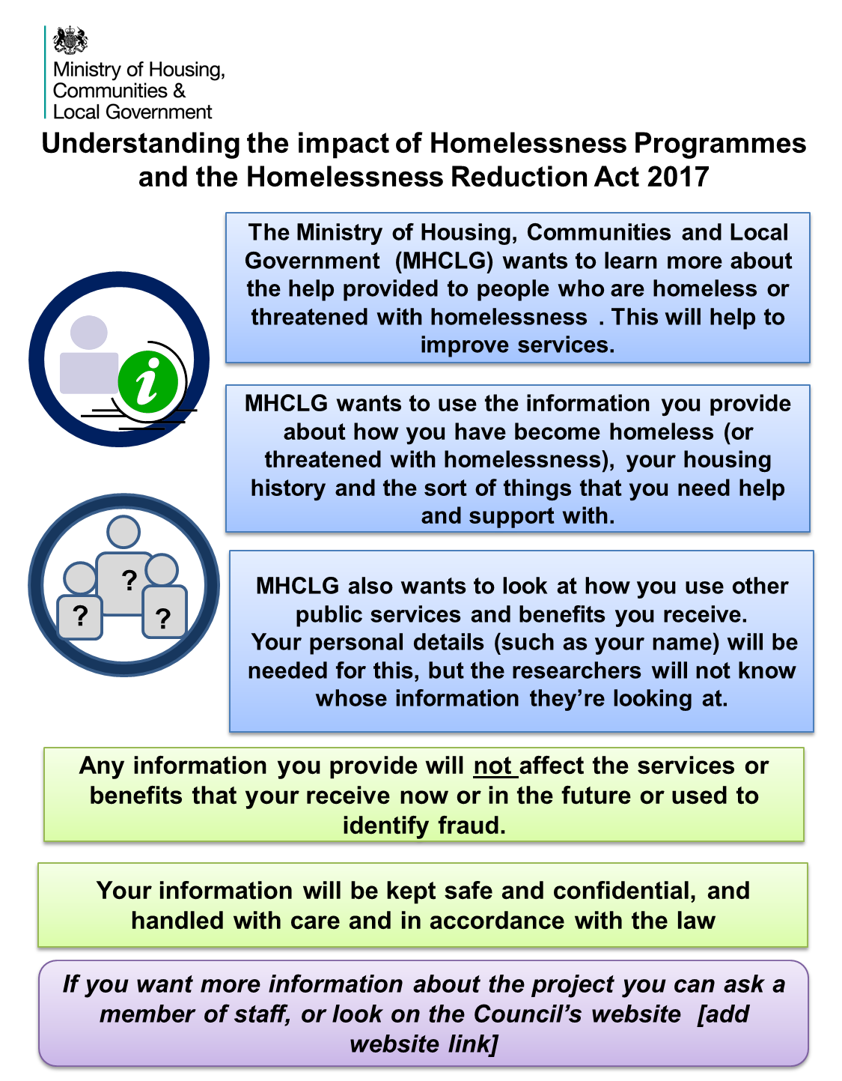

Draft privacy notice/information leaflet (H-CLIC): collecting personal data

[This is a draft version of a privacy notice that can be given out if requested or put on the Council’s website]

Study Title: Understanding more about what causes homelessness and how well homelessness services meet peoples’ needs
This research is being carried out by the Ministry of Housing, Communities and Local Government (MHCLG).
What’s the aim of this study?
By carrying out this research, MHCLG aims to find out whether:
- Housing services prevent homelessness
- People return for help and/or move regularly
- Homelessness programmes, such as Housing First, reduce homelessness
- There are other causes of homelessness and outcomes, such as poor health.

To do this, MHCLG wants to link information about you and others in your household together with other information, including your homelessness application and past and future information on your use of services and benefits.
MHCLG will use your personal information - name, date of birth, gender, last known address, National Insurance number (if known) - to gather the right data held by other government agencies.
Any information you provide will not be used to make any decisions about what benefits you get, services you use, now or in future, or used to identify fraud.
Whose data are you collecting?
We want to collect data on all people asking for help with homelessness.
What’s involved?
At your assessment you will be asked questions about:
- Your experiences of homelessness
- Your support needs
- Whether you have spent time in local authority care, and your current employment status.
What will happen to the information provided?
Your information will only be used for research and will be anonymised so the researchers will not know whose data they have.
Your local authority will send your information to MHCLG using a secure IT system.
Your personal information (name, date of birth, gender, last known address) will be used to identify data collected as part of your assessment and linked to information held by other government departments:
- Department for Work and Pensions (DWP) – to see what benefits you have received and whether you have been employed
- Ministry of Justice (MOJ) – to see what contact you may have had with the criminal justice system
- Department for Education (DfE) – to see when your child has been in school, how well they are doing at each Key Stage and whether they are a Child in Need.
Your information will be kept strictly confidential. Your name, date of birth, gender, address and National Insurance number will be kept separately from all the other information in a secure, password-protected document on a computer system. You will be assigned a unique reference number, so that even though a researcher will see all your information, they will not be able to know it is you.
How long will my information be kept for?
DWP, DfE and MOJ will only keep your personal information for a month and will not keep records showing you were part of this research.
MHCLG will keep your personal information for five years.
We will only use your data within the terms of data protection laws, will delete your data securely and only keep it for as long as necessary. We will review dates for keeping personal data in the future and if necessary update these privacy notices.
To legally share data for this research, local authorities and MHCLG will rely on the Digital Economy Act 2017.
[as the data sharing codes of practice and regulations are still being drafted and agreed this will need to be updated].
The collection of personal information by MHCLG for this project is compliant with data protection legislation.
Your local authority will collect your personal data under the public task basis (in this case to provide housing services) and agree to share this data with MHCLG under the public task basis (in this case to reduce homelessness).
MHCLG will rely on the following reasons for processing personal data and additional special category data below:
A. Lawful basis for processing personal data under Article 6 GDPR
The processing is necessary for this reason:
- Public task: the processing is necessary for you to perform a task in the public interest or for your official functions, and the task or function has a clear basis in law.
B. Additional condition for processing special category data under Article 9(2) GDPR
Special category personal data may be processed if:
(g) processing is necessary for reasons of substantial public interest, on the basis of Union or Member State law which shall be proportionate to the aim pursued, respect the essence of the right to data protection and provide for suitable and specific measures to safeguard the fundamental rights and the interests of the data subject;

- The DPA 2017 will provide a lawful basis to process criminal offence data (as required by Article 10 GDPR).
What are my rights?
You can talk to your local authority about whether your data is being used for this project without it affecting your legal rights or routine care. You can also see copies of all the data MHCLG hold about you and ask for it to be corrected or deleted.
What if I want more information?
If you want more information you can ask a member of staff. You can also contact MHCLG’s Knowledge and Information Team about seeing your data or withdrawing from the research by emailing MHCLG’s Data Protection Officer at dataprotection@communities.gsi.gov.uk
If you are unhappy with the way your personal information is being handled you can contact the independent Information Commissioner at: Home | ICO
What will happen to the results of this research?
The final results of this research will be published on the main government website. You will not be identified in any research report.

