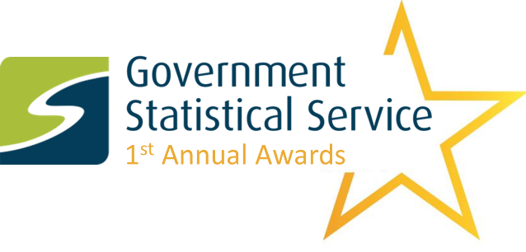

1st Annual GSS Awards

Nomination Form

The GSS Awards recognise and celebrate the excellent work being done across the Government Statistical Service. We welcome nominations which reflect the range of work completed by statisticians, analysts and other professions. The awards are not limited to published statistical outputs. The 2019 GSS Awards recognise work carried out between 1st July 2018 and 30th June 2019.

There are four awards: Collaboration, Methods, Communication and Impact which will be presented to teams from across the GSS.

Collaboration
This award recognises collaboration between teams, departments and/or external organisations/researchers to deliver a statistical output or project. The judging panel will consider the following when judging nominations for this award:

- Collaboration which improved data and methods
- Ways of working which enabled effective collaboration
- Collaboration which enhanced the insight and understanding of the findings
- Collaboration with stakeholders such as other teams in your department, other government departments, organisations outside government, topic and method experts, other analytical professions, policy professionals, producers of related statistics, international organisations and researchers.
Methods
This award recognises innovation in methods of data collection, statistical analysis and data science. The judging panel will consider the following when judging nominations for this award:

- Innovative data collection, statistical analysis or data science methods used
- Methods which led to new insight, answered complex questions, or improved efficiency
- The strengths and limitations of the methods used were considered, and communicated effectively to users
- Feedback from peer reviewers and experts was invited and acted upon to refine the methods
Communication
This award recognises clear and successful presentation and dissemination of statistics using commentary, visualisations, interactives, social media etc. The judging panel will consider the following when judging nominations for this award:

- Use of innovative methods of communicating and disseminating statistics
- Statistics presented clearly, explained meaningfully and that provide insights which serve the public good
- The needs of different types of users and potential users were considered when determining how the statistics would be communicated
- Statistics communicated in a way that engaged users and encouraged appropriate reuse of the statistics
Impact
This award recognises statistics which have been impactful through use, influenced decisions made by policy-makers, politicians or the public and/or have contributed to public debate. The judging panel will consider the following when judging nominations for this award:

- A demonstrable link between the statistics and impact. For example, is there evidence to show that the statistics influenced a policy decision?
- The nature and significance of the impact from the users' point of view (user feedback can be provided). Actual delivered impact will be considered more effective than anticipated or future potential impact.
- The nominated team were pro-active in ensuring the statistics have impact.
- New statistics or analysis developed to meet an identified knowledge or information gap.

Person making the nomination

Please provide details of the person completing this nomination form (We require dietary requirements to assist with the allocation of places for the GSS conference):

Name:
Job title:
Organisation:
Telephone:
Email:
Dietary requirements? (Yes/No)
If yes, then please provide details:

Nomination details

Please provide details about the work you are nominating, including the chosen award category. We require dietary requirements to assist with the allocation of places for the GSS conference:

Title of nomination:
Name of nominated team:
Department of nominated team:
Team members involved: | Name Email Dietary requirements? (Yes/No) Details of dietary requirements
Award nominating for: | Choose an item.
Brief description: (max 100 words)
Considering the above information, briefly describe how this nomination achieves excellence in one of the four award categories. Please also provide any URL links that support your entry (max 1,000 words)

Main contact for the nomination

We require a main contact from the nominated team who would accept the award at the awards ceremony on behalf of the nominated team. We will guarantee a conference place for the main contact provided for all nominations that get shortlisted.

Please provide details of the main contact in the team being nominated (if this is the same as the person completing this nomination which was provided above then leave this blank):

Name:
Job title:
Organisation:
Telephone:
Email:
Dietary requirements? (Yes/No)
If yes, then please provide details:

Submitting your entry

All entries must be submitted by midnight on 18th August 2019 to GSShelp@statistics.gov.uk Entries should be marked as “GSS Awards 2019 submission”.

The Awards will be judged by the following expert panel:
- Siobhan Carey: Head of Profession for Statistics, NISRA
- Robert Cuffe: Head of Statistics, BBC News
- Ed Humpherson: Director General for Regulation, UKSA
- Neil McIvor: Head of Profession for Statistics, DfE
- Julie Stanborough: Head of Best Practice & Impact Division, ONS
Should the award administrators determine that a nomination is suitable for another award, they may re-categorise the nomination. In the event of this happening, the person who submitted the entry will be contacted.

The awards ceremony will be held in the evening session of the GSS conference on the 1st October 2019 in Edinburgh. The award administrators require a main contact to be provided for each nomination who would accept the award at the awards ceremony on behalf of the nominated team. We will guarantee a conference place for the main contact provided for all nominations that get shortlisted. We will endeavour to allocate conference places to as many other team members as possible in the shortlisted teams.

Any queries should be directed to GSShelp@statistics.gov.uk.

